CS-322 Software Construction
Data Dictionary


Project Management System

PRESENTED BY
Name 1: Muhammad Rayyan (LEADER) (04072312024)

SUPERVISED BY
Dr. Onaiza Maqbool

Department of Computer Science
Quaid-e-Azam University, Islamabad

Member Name | Use-case Text and System Sequence  Diagram
Muhammad Rayyan | UC 1,2 & SSD 1,2

Use-Case Text

UC 1: Offer projects and assign supervisors
- Primary Actor:
Administration

- Precondition:
The system must be operational, and the admin must be logged in.

- Main Success Scenario:
- The administrator will enter the project details which include project title, project description etc.
- The administrator will assign supervisors to the projects.
- The system will save and publish the projects.

- Alternate Scenario:
1.2 If project details are incomplete, then the prompts for missing information.
1.3 If the supervisor is unavailable, the system prompts for another selection.

- Postcondition:
Projects are available for students to register, and supervisors are assigned.

UC 2: Project Registration
- Primary Actor:
Student

- Precondition:
The students must have a valid user account.
- Main Success Scenario:
- Students browse the available projects.
- Student selects a project and submits a request for registration.
- The system confirms the registration.
- Student receives confirmation of registration.

- Alternate Scenario
2.4 If the student changes their mind, they can cancel the registration.

- Postcondition:
The project is registered under the student along with the supervisor.

System Sequence Diagram

UC 1: Offer projects and assign supervisors
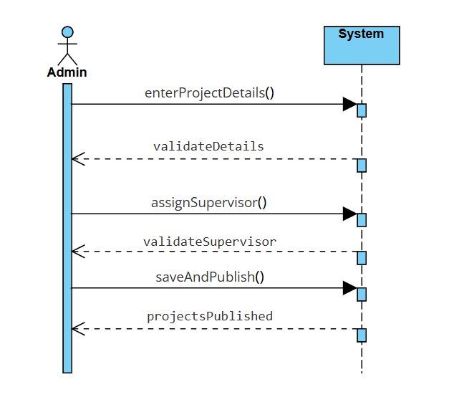

UC 2: Project Registration
